Want to take charge of HIV and your general health?
Become a Self-Manager!
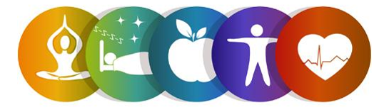
Register for the Positive Self-Management Workshop!
This six-week workshop is part of the Chronic Disease Self-Management Program and is FREE to adults 60 and older.
In light of COVID-19, this will be offered virtually!

Participants with HIV will learn new ways to take charge of their health and learn tips to manage symptoms, nutrition, pain, medication, stress, depression, fatigue and overcome physical limitations.

making a healthy eating plan, managing blood sugar levels, balancing eating, physical activity and medications to prevent problems as well as managing diabetes-specific problems.

Workshop Details:
This six-week workshop meets weekly on Tuesdays via Zoom. Participants will receive materials including the book, Living A Healthy Life with HIV in the mail at no cost.
Dates: May 25th, June 1st, 8th ,15th, 22th, 29th Time: 10am to 12:30pm

Time: 10am-12:30pm

To register, contact:
Stephen Merrill
Health Promotion Nurse Supervisor
(215)765-9000 ext. 5123 Stephen.merrill@pcacares.org

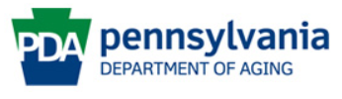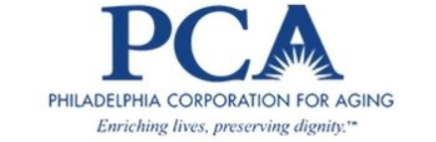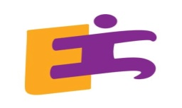
This program is presented by Philadelphia Corporation for Aging and the LGBT Elder Initiative through Title IIID funds received from the Pennsylvania Department of Aging. This program was originally developed at Stanford University and is now owned by Self-Management Resource Center, Inc.

