Want to Take Charge of Your Diabetes?
Become a Self-Manager!
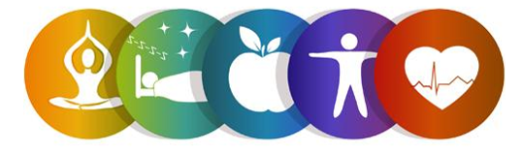
Register for the Common Threads Workshop!
This six-week workshop is part of the Diabetes Self-Management Program and is FREE to adults 60 and older.
In light of COVID-19, this will be offered virtually!

Participants will learn about making a healthy eating plan, managing blood sugar levels, balancing eating, physical activity and medications to prevent problems as well as managing diabetes-specific problems.

Workshop Details:
This program will be held on Thursdays via a conference call line. All participants will be mailed a Self-Management Tool Kit at no cost.
Dates: April 29th, May 6th, 13th, 20th, 27th, and June 3rd
Time: 10am – 12:30pm

To register, contact:
Lauren Jirinec
Health Promotion Specialist
(215)765-9000 ext. 5119 Lauren.Jirinec@pcacares.org

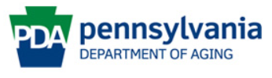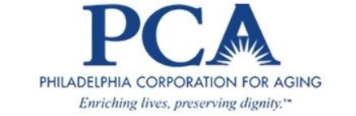
This program is supported by Philadelphia Corporation for Aging through Title IIID funds received from the Pennsylvania Department of Aging. This program was originally developed at Stanford University and is now owned by Self-Management Resource Center, Inc.

