Want to Take Charge of Your Health?
Become a Self-Manager!
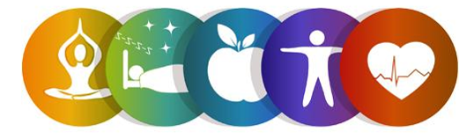
Register for the Help Yourself to Health Workshop!
This six-week workshop is part of the Chronic Disease Self-Management Program and is FREE to adults 60 and older.
In light of COVID-19, this will be offered virtually!

Participants with chronic conditions such as high blood pressure, asthma, heart disease, and diabetes will learn new ways to take charge of their health and learn tips to manage pain, depression, and overcome physical limitations.

making a healthy eating plan, managing blood sugar levels, balancing eating, physical activity and medications to prevent problems as well as managing diabetes-specific problems.

Workshop Details:
This six-week workshop meets weekly on Wednesdays via Zoom. Participants will receive a Self-Management Tool Kit in the mail at no cost.
Dates: April 14th, 21st, 28th, May 5th, 12th, 19th
Time: 10am-12:30pm

To register, contact:
Lauren Jirinec
Health Promotion Specialist
(215)765-9000 ext. 5119 Lauren.Jirinec@pcacares.org

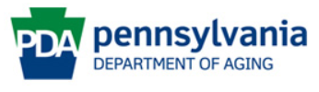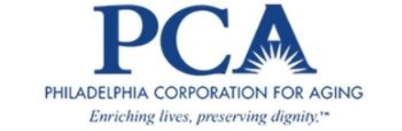
This program is supported by Philadelphia Corporation for Aging through Title IIID funds received from the Pennsylvania Department of Aging. This program was originally developed at Stanford University and is now owned by Self-Management Resource Center, Inc.

